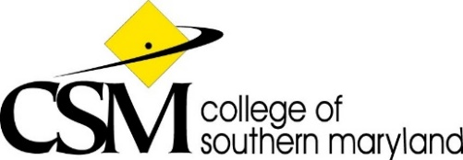
Talent Development Council
AGENDA
Microsoft Teams
May 27, 2021, 2:30 PM – 3:30 PM

Ref | Topic | Lead Person | Time
1 | Call to Order | Laura | 2:30 PM
2 | Approval of Agenda (Discussion) | Laura | 2:30 PM
3 | Approval of Minutes | Laura | 2:35 PM
4 | Chair’s Report  - 5/19 CWC Meeting & Forum Presentation  - CWC Handbook Update  - Constitution & Bylaws Update | Jesse  Jesse  Laura | 2:45 PM
5 | Committee Reports | N/A | N/A
6 | Unfinished Business  - Council Assistant  - Review recommendations for HR4020  - Telecommuting Policy – Due June 7th | Laura  Jesse & Laura  Jesse & Laura | 3:00 PM
7 | New Business  - Process Reimagine and Redesign (PRR) Developing the Ideal Employee Experience Workshop | All Attendees | 3:15 PM
8 | Adjournment | Jesse | 3:30 PM

Council Liaisons: Trenace Richardson, Craig Patenaude
Next Council Meeting Dates:
August 26, 2021, 2:30PM - 3:30PM (Tentative)
September 23, 2021, 2:30PM - 3:30PM (Tentative)
October 28, 2021, 2:30 - 3:30PM (Tentative)

