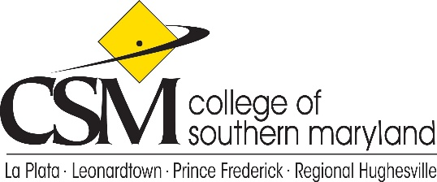

College Planning Council
Agenda
April 8, 2021

- Call to Order
- Approval of the Agenda
- Approval and Review of the March 11, 2021 minutes
- 2021-2024 Draft Institutional Strategic Plan – Erin Ebersole
- Recruitment and Enrollment Plan Briefing - Carol Harrison, Interim Dean of Enrollment Services
- Student Completion Plan Briefing - Michelle Ruble, Interim Dean of Student Development
- College Wide Council Updates – Lesley Quattlebaum
- Unfinished Business
- New Business
- Adjournment

Future Meetings: May 13th- No June, July, August

May: Marketing Overview (Avis McMillion)

