Instructional and Student Affairs Council (ISA)

Meeting Agenda

Thursday January 7, 2021

2:30 pm
Co-Chairs: Stephanie McCaslin and Kelly Winters
- Welcome of Guests
- Amy Carney: CIC report
- Carol Harrison (ISAC member): ASP report
- Shelby Potts: K-16 report
- Discussion item: Prior Learning Assessment
- Future items- open discussion
- Assignments and adjuornments

K-16 Committee (Mitchell Levy and Shelby Potts)
- Dual Enrollment student success and access to CSM resources, as well as high school teacher access to CSM resources such as MyLearning and support for Dual teachers
- MOU’s for Dual Courses

Academic Standards and Policies (Carol Harrison)
- Reviewing credit for prior learning/portfolio process is scheduled for our December meeting
- Catalog Policies to Review this year’s cycle 2020-2021
  - Academic Clemency Policy Change – September 2020
  - Summer & 7-week Course Loads
  - Last day to add a class 15-week & 7-week
  - P-grade – extenuating circumstances
  - Re-write Placement test procedures
  - Departmental Exams
  - Advising requirement - Advisor holds A18 & A36
  - Student Appeals process
  - Academic Standing
  - Prerequisites & Corequisites

Curriculum and Instruction Committee (Laura Polk and Amy)
- Changes to curriculum (courses and programs) for the upcoming catalog
- Upcoming on the agenda for CIC will be the New Honors courses

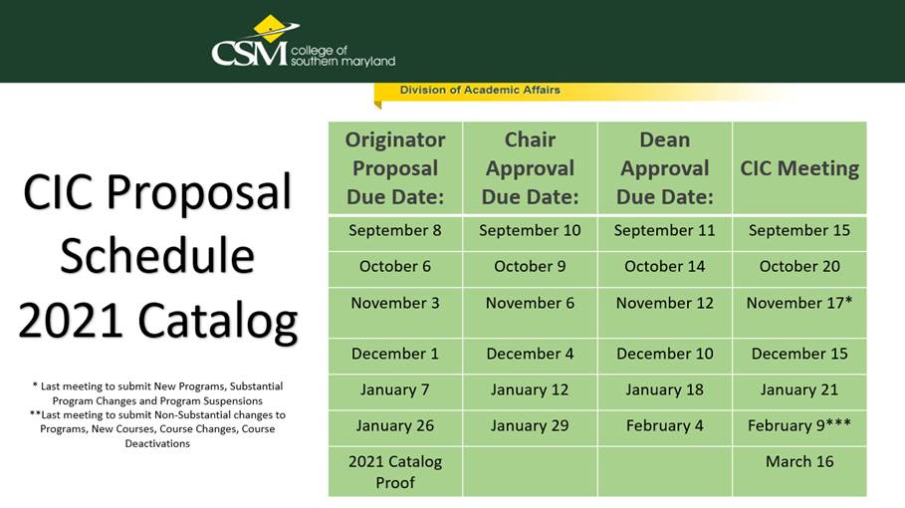
Policies are on a reviewed every 3-5 years depending on how much we are able to accomplish each year.

